EXPERIMENT 9

Create table bank
CREATE TABLE BANK_5 (
bankcode VARCHAR(3) PRIMARY KEY,
bankname VARCHAR(50) NOT NULL,
headoffice VARCHAR(50),
branches INT CHECK (branches > 0)
);
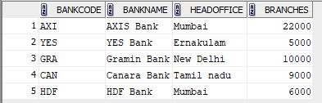
CREATE TABLE BRANCH
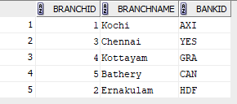

INSERTED VALUES

INSERT INTO BANK_5 VALUES ('AXI', 'AXIS Bank', 'Mumbai', 22000);
INSERT INTO BANK_5 VALUES ('HDF', 'HDF Bank', 'Mumbai', 6000);
INSERT INTO BANK_5 VALUES ('YES', 'YES Bank', 'Ernakulam', 5000);
INSERT INTO BANK_5 VALUES ('GRA', 'Gramin Bank', 'New Delhi', 10000);
INSERT INTO BANK_5 VALUES ('CAN', 'Canara Bank', 'Tamil nadu', 9000);
CREATE TABLE BRANCH (
branchid INT PRIMARY KEY,
branchname VARCHAR(50) DEFAULT 'Ernakulam',
bankid VARCHAR(3),
FOREIGN KEY (bankid) REFERENCES BANK_5 (bankcode)
);
INSERT INTO BRANCH VALUES (1, 'Kochi', 'AXI');
INSERT INTO BRANCH VALUES (2, 'Ernakulam', 'HDF');
INSERT INTO BRANCH VALUES (3, 'Chennai', 'YES');
INSERT INTO BRANCH VALUES (4, 'Kottayam', 'GRA');
INSERT INTO BRANCH VALUES (5, 'Bathery', 'CAN');

VIEWS CREATED

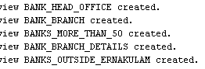

# CREATE VIEW bank_head_office AS
SELECT *
FROM BANK_5
WHERE headoffice = 'Ernakulam';

# CREATE VIEW bank_branch AS
SELECT B.*
FROM BANK_5 B
JOIN BRANCH BR ON B.bankcode = BR.bankid
WHERE BR.branchname = 'Kottayam';

# CREATE VIEW banks_more_than_50 AS
SELECT *
FROM BANK_5
WHERE branches > 50;

# CREATE VIEW bank_branch_details AS
SELECT B.bankname, BR.branchname
FROM BANK_5 B
JOIN BRANCH BR ON B.bankcode = BR.bankid;

# CREATE VIEW banks_outside_ernakulam AS
SELECT *
FROM BANK_5
WHERE headoffice <> 'Ernakulam';
The condition <> 'Ernakulam' means not equal to Ernakulam
SELECT * FROM banks_outside_ernakulam;

1)
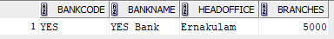

2)
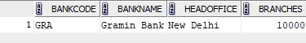

3)
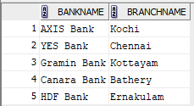

4)
